Semester Project Options - Fall 2018

The Semester Project is what that ties together the two main topics this semester.

* **Programming** (what we have done up until now if you are in doubt ;-)
* **System Development**. A new topic starting October 9th. This topic has its own exam, based on a report on theory and praxis during the semester project.

The Project you come up with must be approved by your product owners (Jan and/or Palle), but in order to continue, getting experience with the technological topics covered this semester, the following are the technological requirements for the project:

* It must include a backend that communicates with a number of other servers. Think Momondo, as sketched below, but feel free to twist it any way you like (Hotels.com, cars, holiday homes, etc.) as long as it includes a similar architecture.
* You must team up, at least two groups, and define a protocol to be used among your server (Momondo below) and the external servers (Airlines below). This, in order to have some “real” backends to communicate with, and having a fixed protocol, also allows you to outsource your “Airline”
* It must include (admin, for example ) pages which can only be accessed by authenticated users
* Ideally (yellow and red students) it should include a simple proof-of-concept mobile app

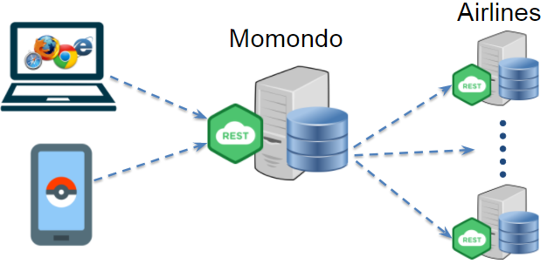

Additional detailed (weekly) requirements will be given by your product owners